SQL Practice — Physician & Department Database

JOINS, GROUP BY, SUBQUERIES & AGGREGATE FUNCTIONS

Name: M.Akhila
Roll No: 2520030511

Section: 7

Step 1 — Create Database
CREATE DATABASE hospital_db; USE hospital_db;

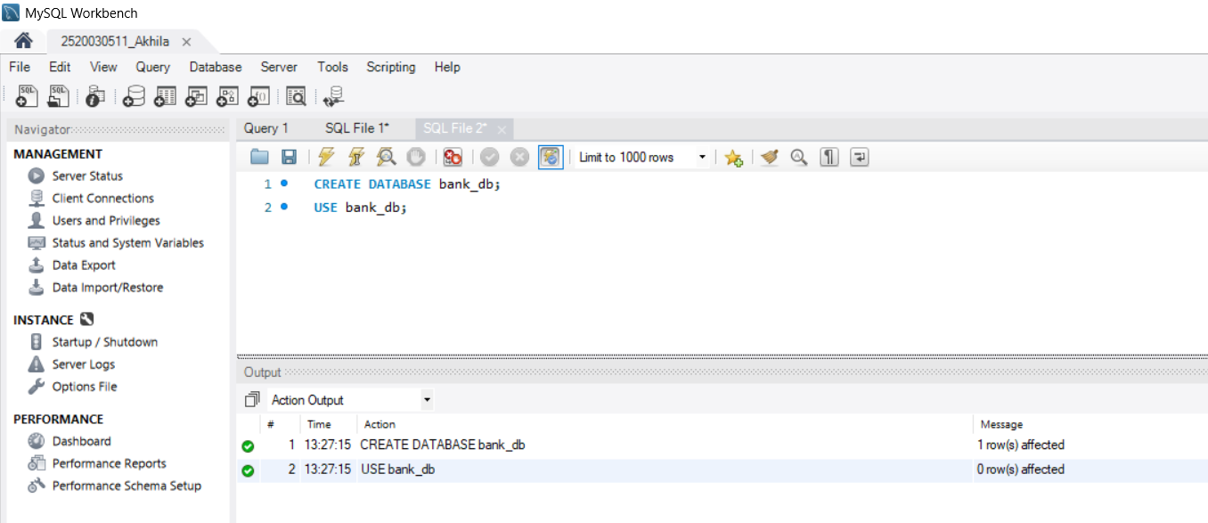

Step 2 — Create Physician Table (DDL)
CREATE TABLE physician ( employeeid INT PRIMARY KEY, name VARCHAR(100),
position VARCHAR(100), ssn VARCHAR(20)
);

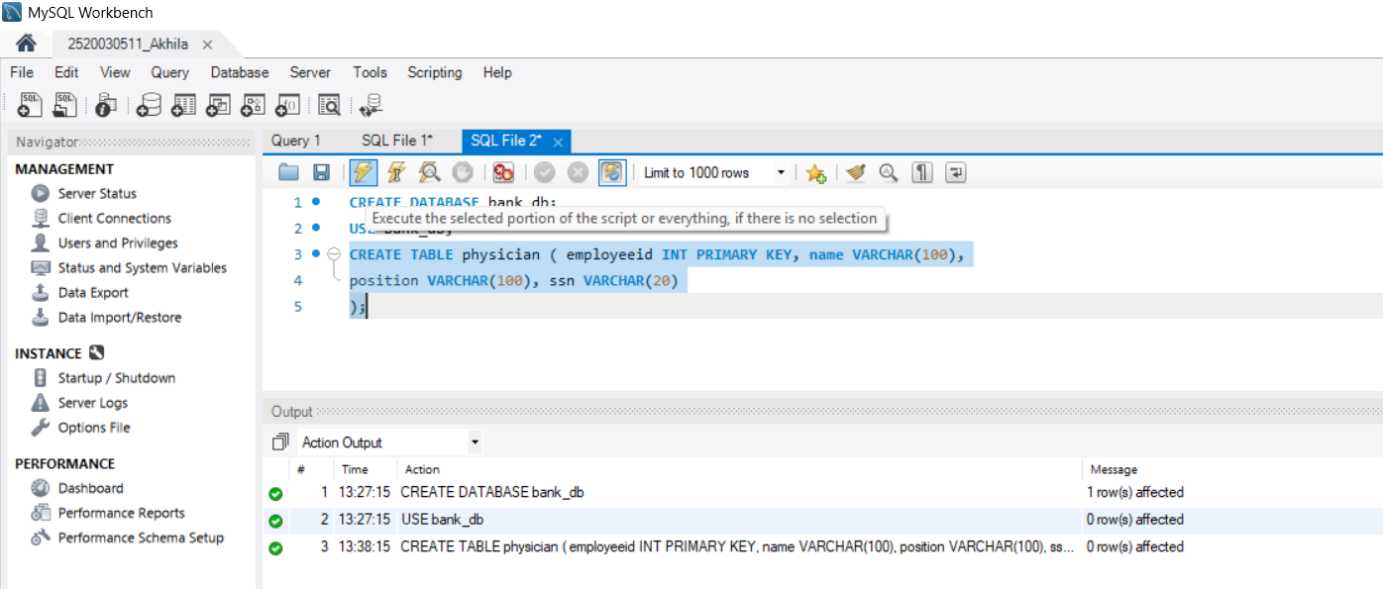

Step 3 — Insert Data into Physician and Display
INSERT INTO physician VALUES
(1,'Hansika Reddy','Staff Internist','111111111'), (2,'Priya Sharma','Attending Physician','222222222'), (3,'Arjun Iyer','Surgical Attending Physician','333333333'), (4,'Aditya Rao','Senior Attending Physician','444444444'), (5,'Rohan Mehta','Head Chief of Medicine','555555555'),
(6,'Vikram Nair','Surgical Attending Physician','666666666'), (7,'Aditya Verma','Surgical Attending Physician','777777777'), (8,'Karthik Iyer','MD Resident','888888888'),
(9,'Sneha Pillai','Attending Psychiatrist','999999999');

SELECT * FROM physician;

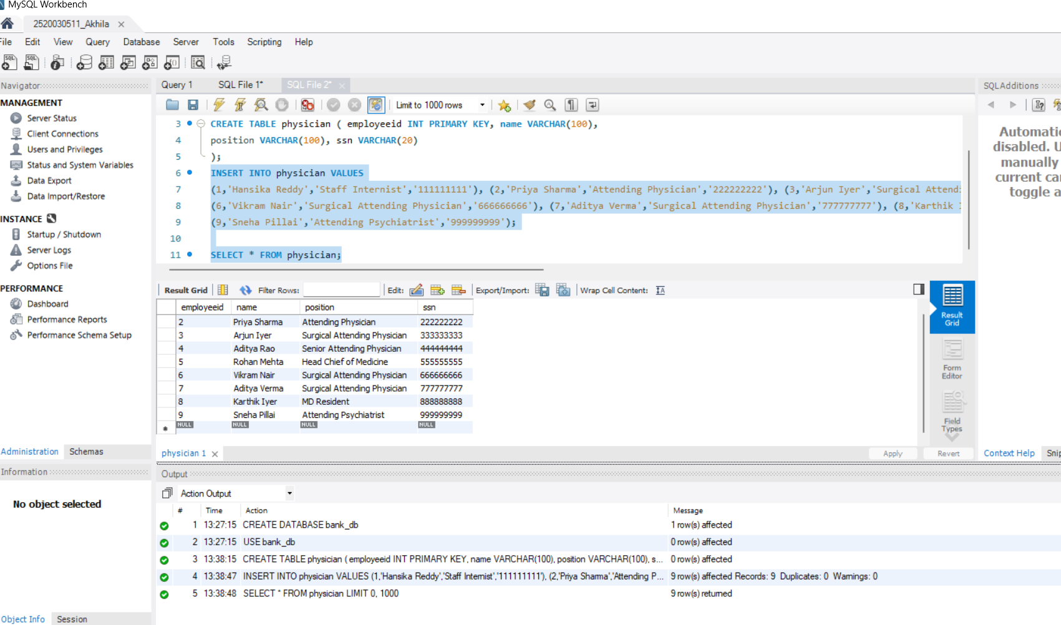

Step 4 — Create Department Table (DDL)
CREATE TABLE department ( departmentid INT PRIMARY KEY, name VARCHAR(100),
head INT
);

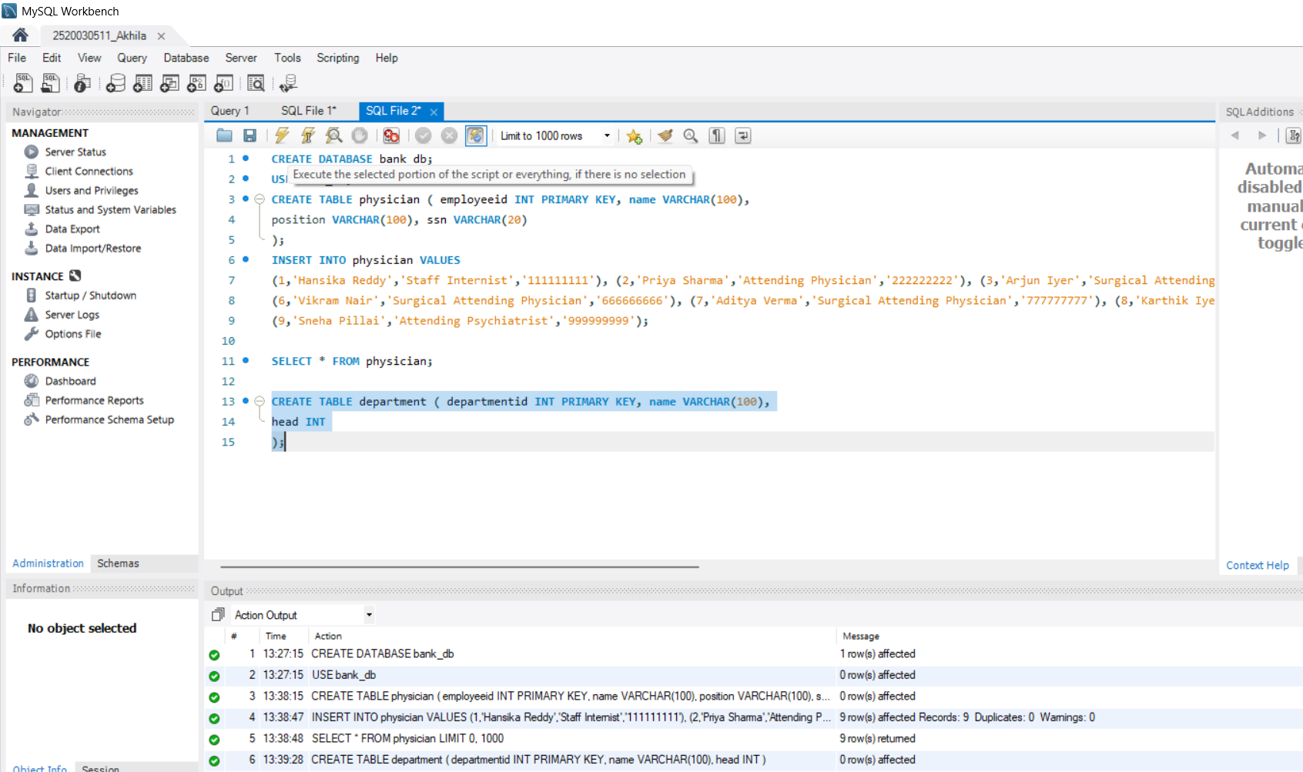

Step 5 — Insert Data into Department and Display
INSERT INTO department VALUES (1,'General Medicine',4), (2,'Surgery',7),
(3,'Psychiatry',9);

SELECT * FROM department;

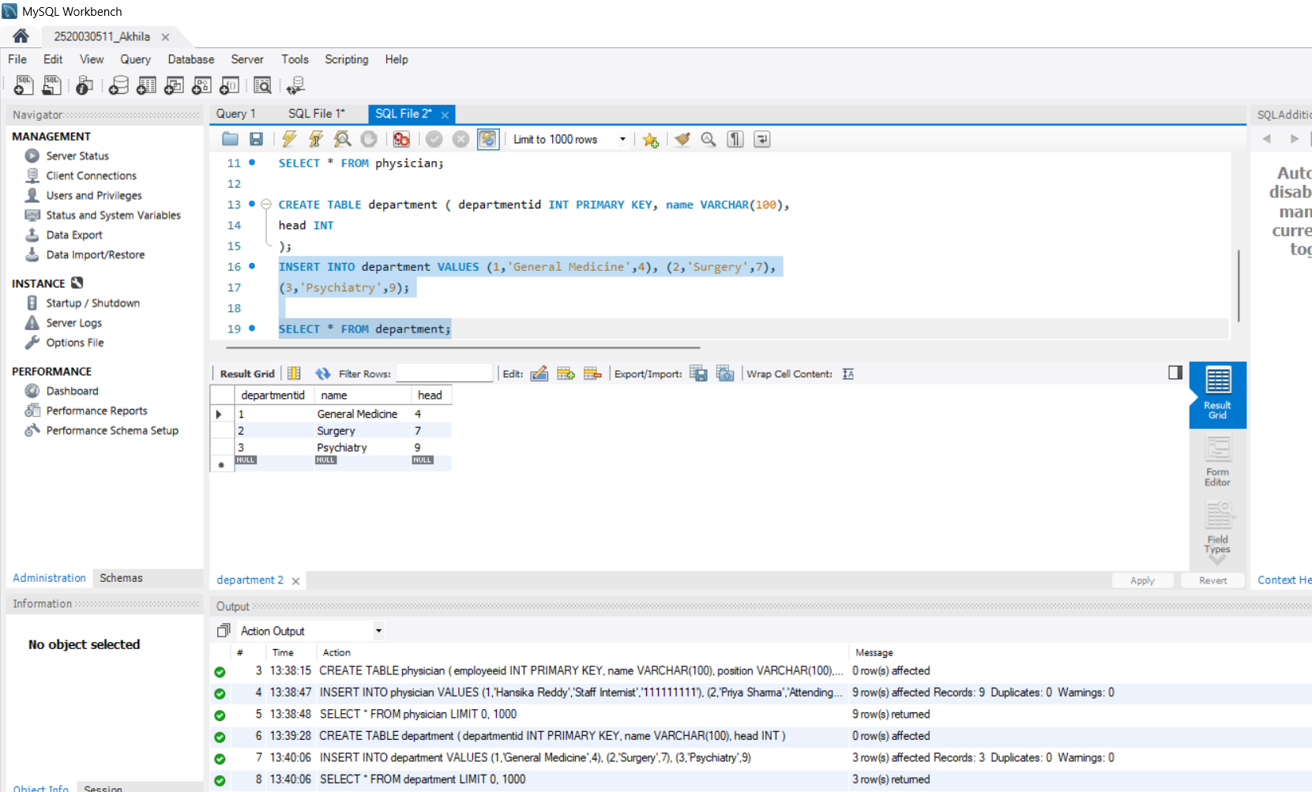

Step 6 — Question 1: INNER JOIN
SELECT d.name AS Department, p.name AS Head_Physician
FROM department d JOIN physician p
ON d.head = p.employeeid;

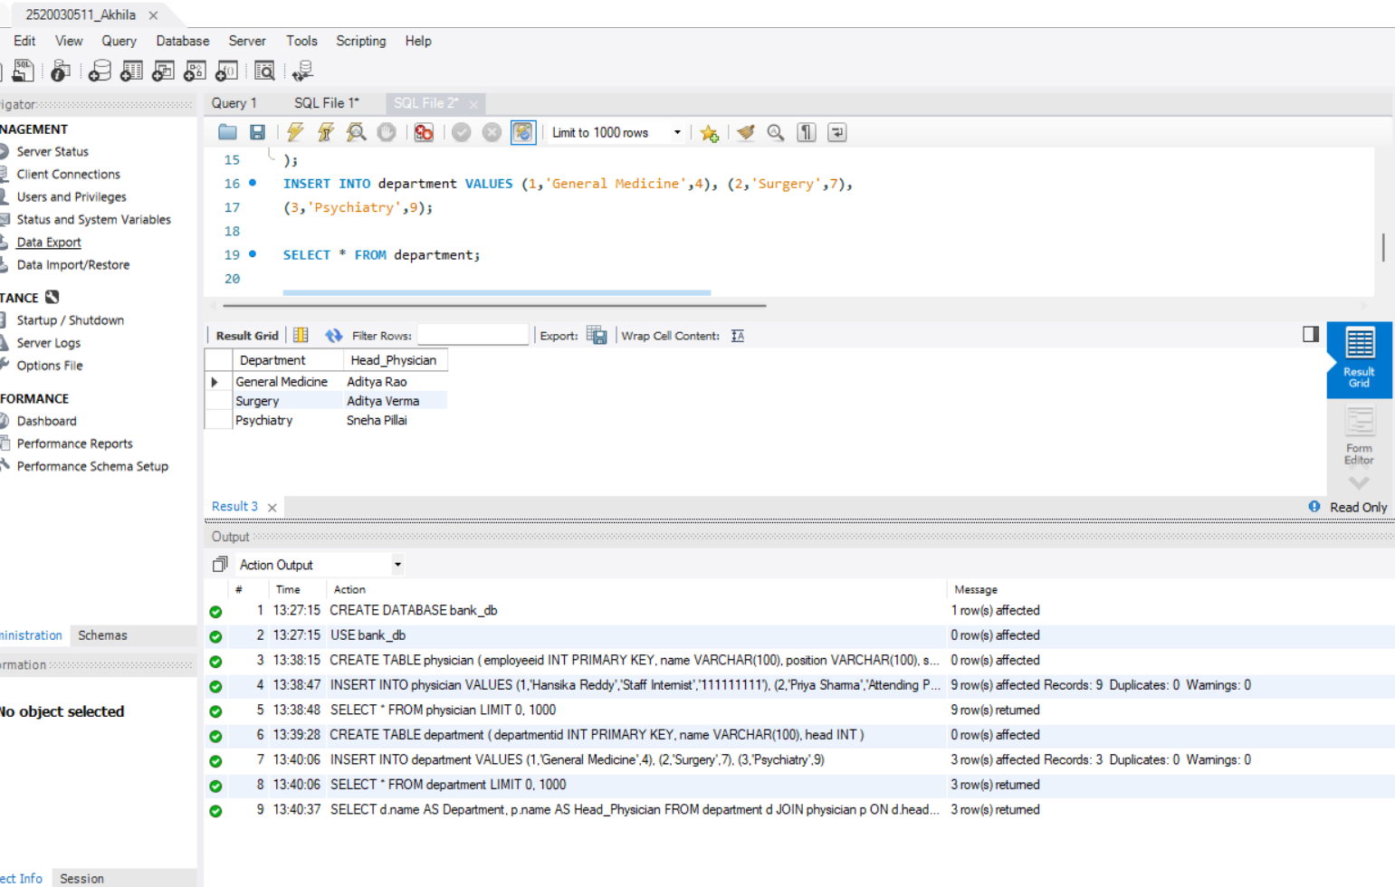

Step 7 — Question 2: WHERE Clause
SELECT *
FROM physician
WHERE position='Surgical Attending Physician';

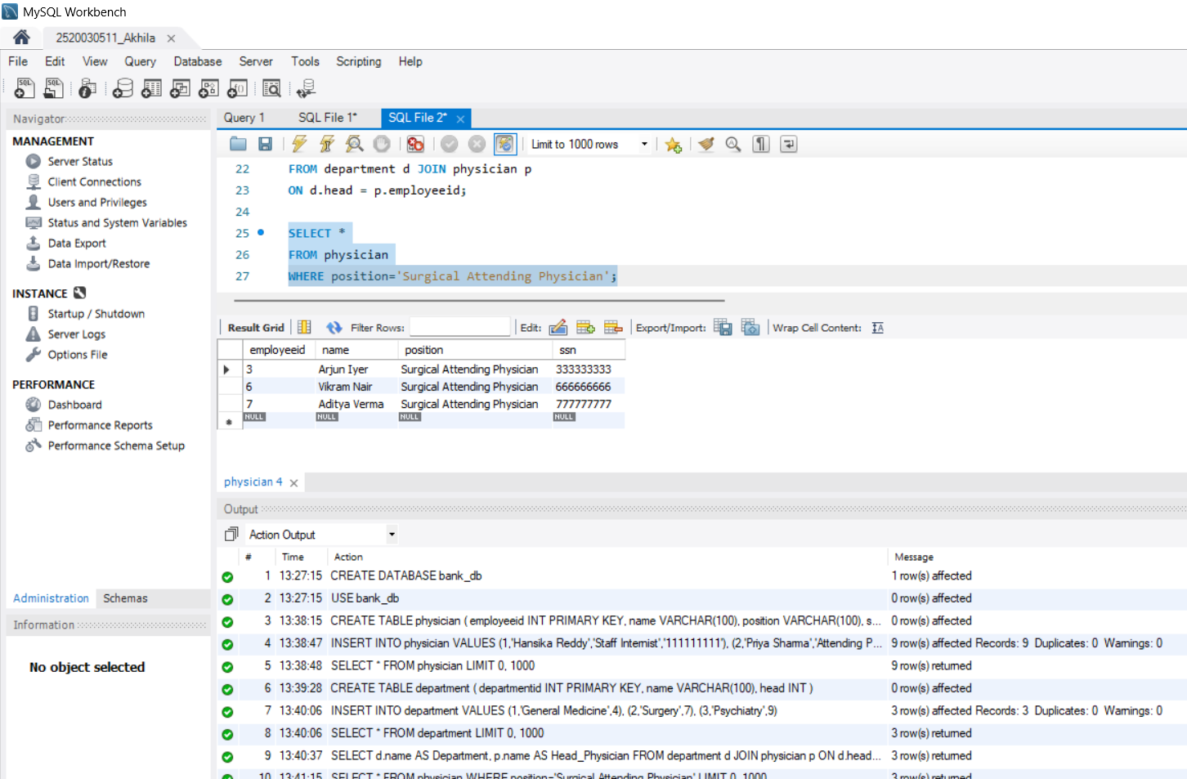
Step 8 — Question 3: WHERE + LIKE
SELECT *
FROM physician
WHERE name LIKE 'Aditya%';
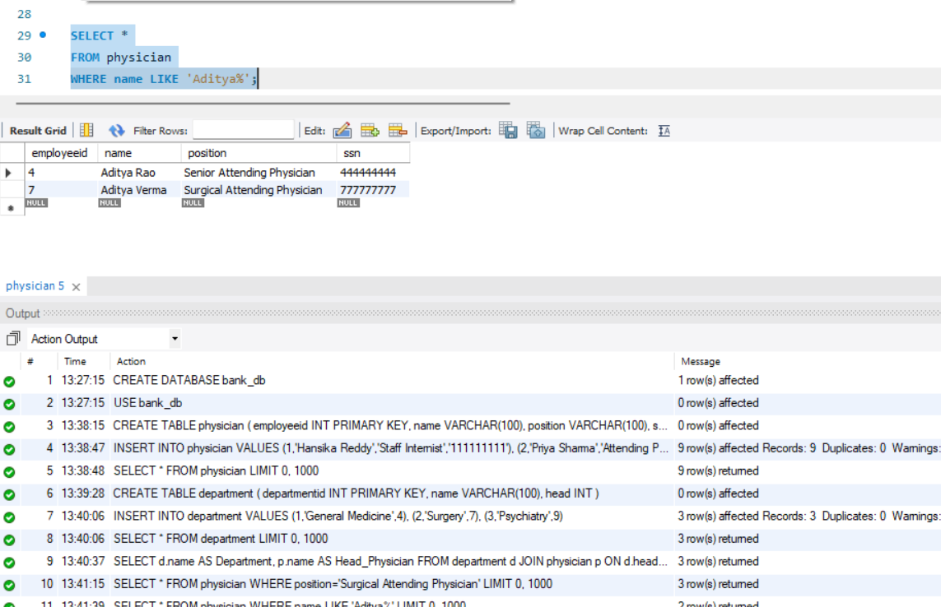

Step 9 — Question 4: COUNT()
SELECT COUNT(*) AS Total_Physicians FROM physician;

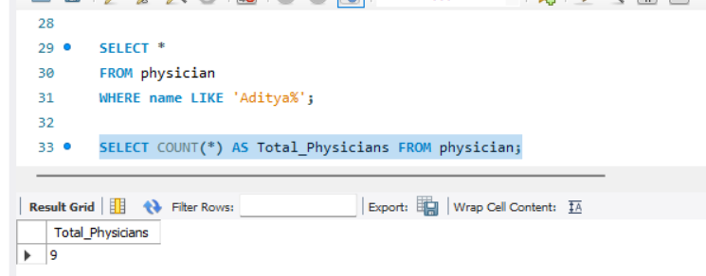

Step 10 — Question 5: COUNT DISTINCT
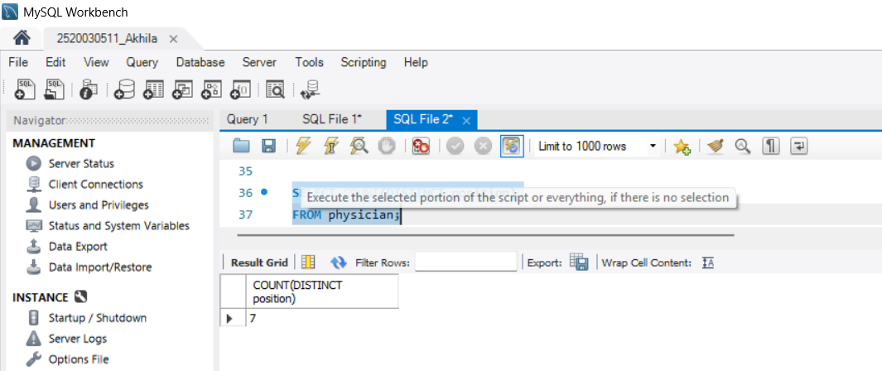
SELECT COUNT(DISTINCT position)
FROM physician;

Step 11 — Question 6: GROUP BY
SELECT position,
COUNT(*) AS Total_Employees FROM physician
GROUP BY position;

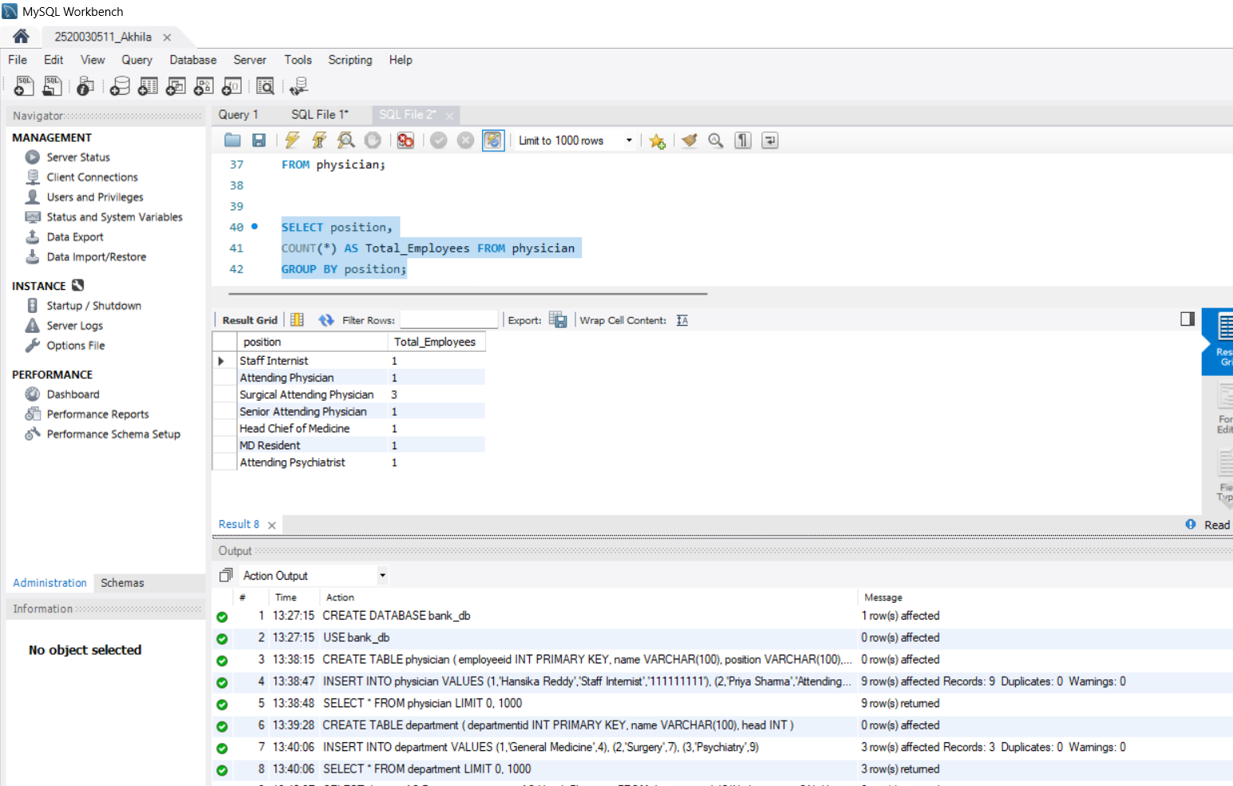

Step 12 — Question 7: GROUP BY + HAVING
SELECT position,
COUNT(*) AS Total_Employees FROM physician
GROUP BY position HAVING COUNT(*) > 1;

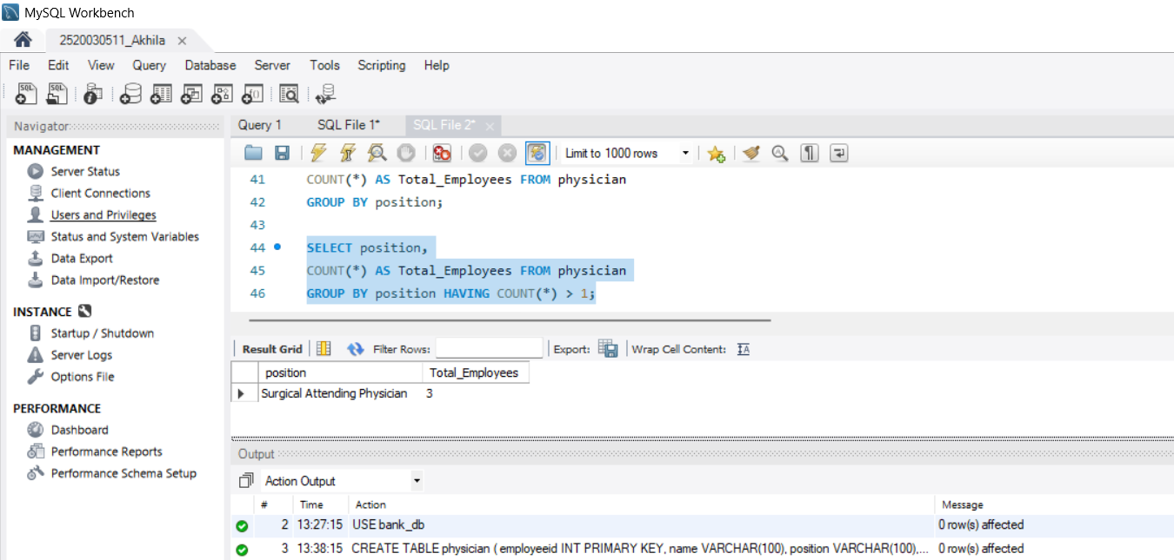

Step 13 — Question 8: ORDER BY
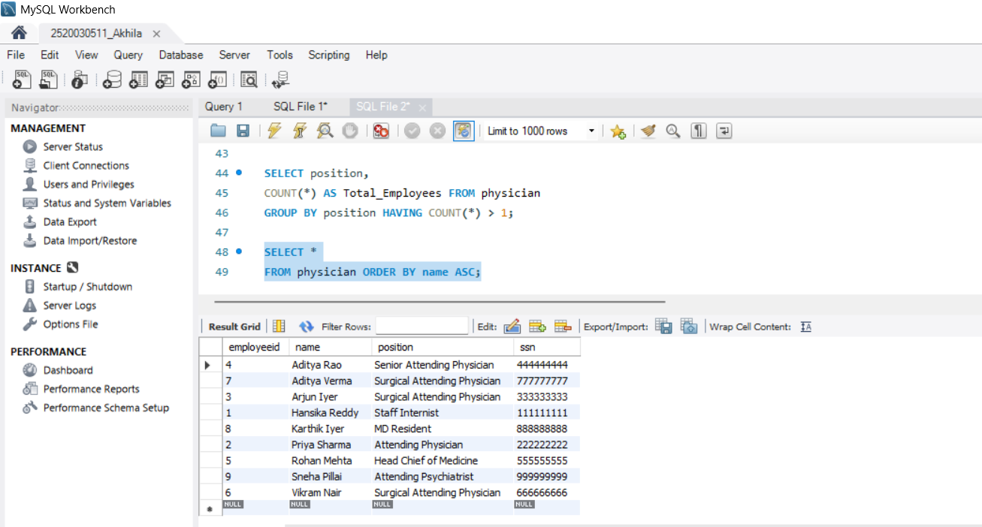

Step 14 — Question 9: ORDER BY DESC
SELECT *
FROM physician
ORDER BY employeeid DESC;

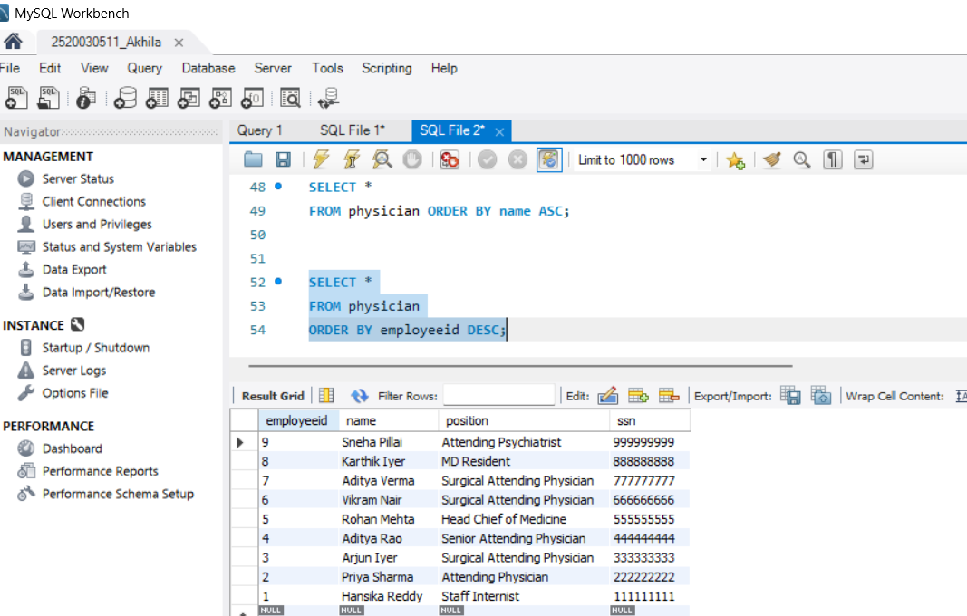

Step 15 — Question 10: WHERE + IN.
SELECT *
FROM physician WHERE employeeid IN (
SELECT head FROM department
);

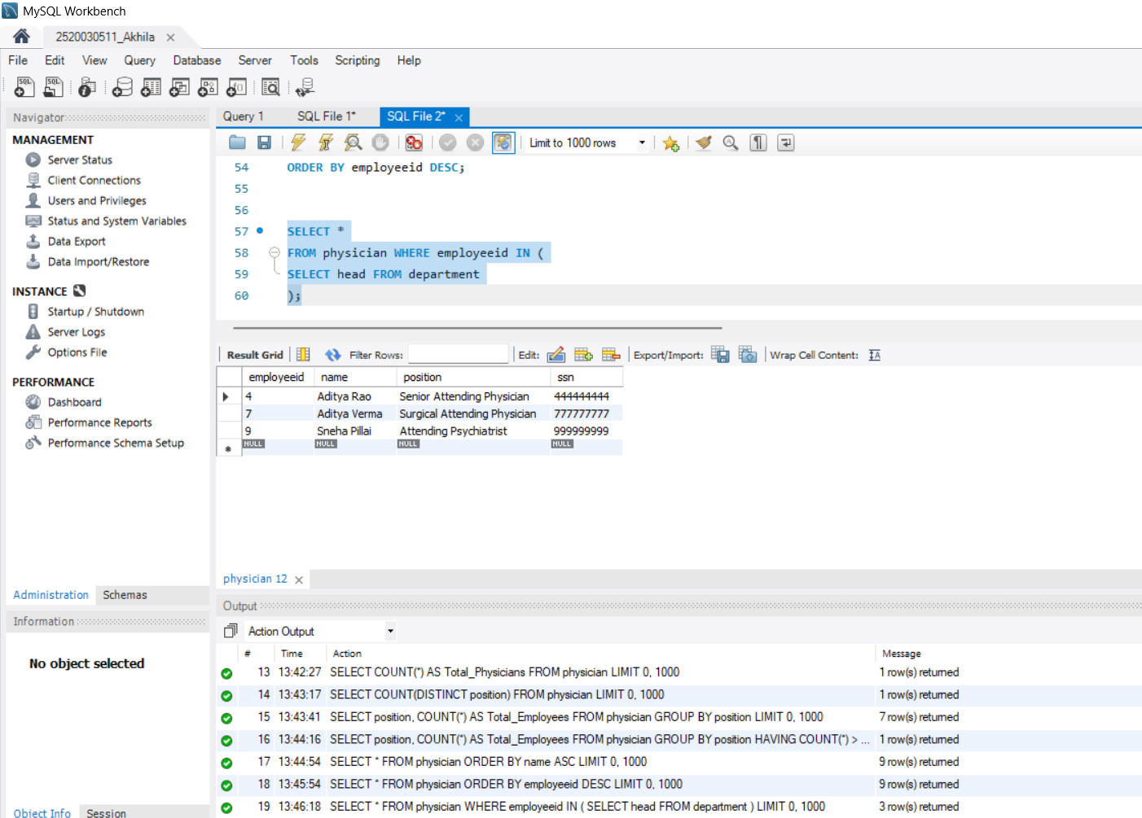

Step 16 — Question 11: Subquery (NOT IN)
SELECT *
FROM physician
WHERE employeeid NOT IN (
SELECT head FROM department
);

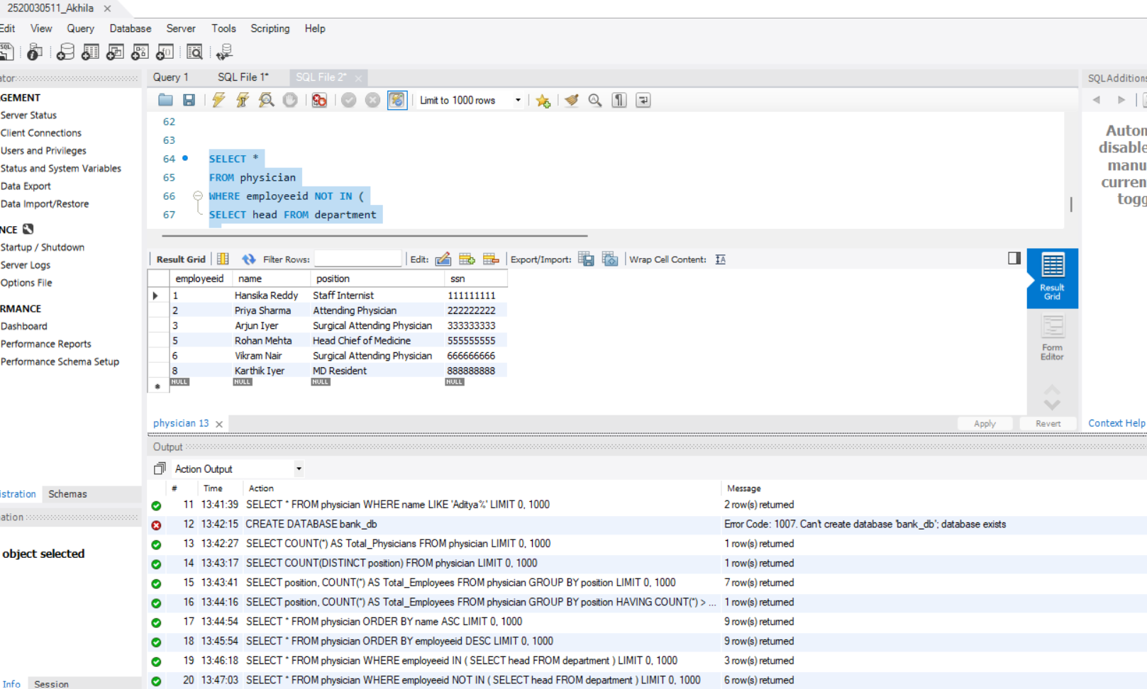
Step 17 — Question 12: GROUP BY + ORDER BY
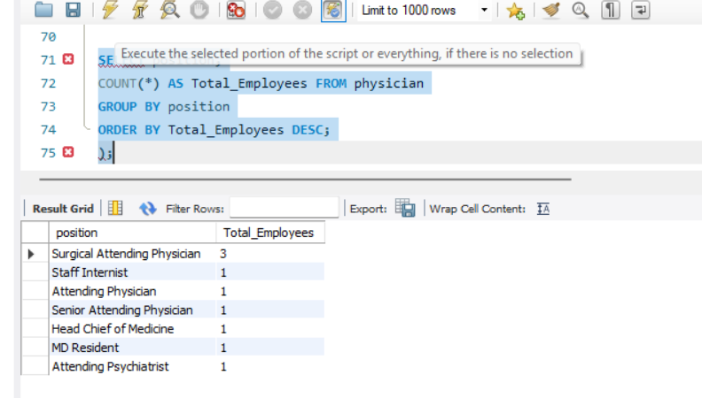
SELECT position,
COUNT(*) AS Total_Employees FROM physician
GROUP BY position
ORDER BY Total_Employees DESC;

Step 18 — Question 13: WHERE + LIKE
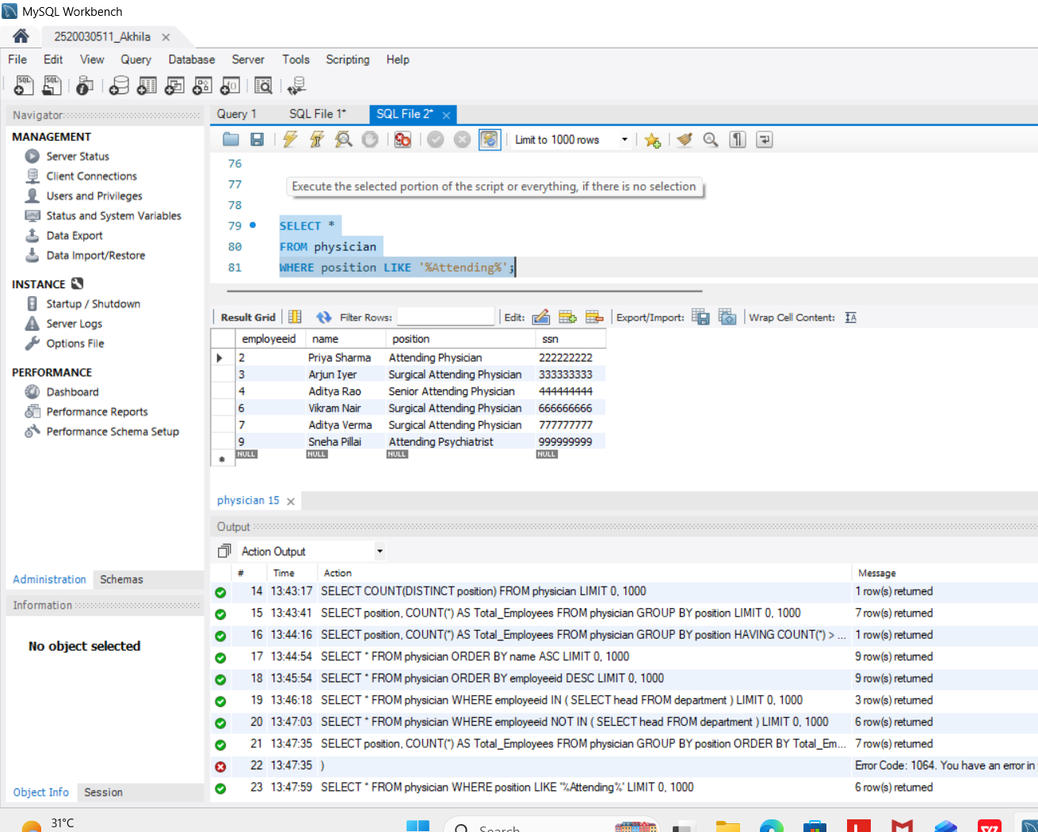
SELECT *
FROM physician
WHERE position LIKE '%Attending%';

Step 19 — Question 14: JOIN + WHERE
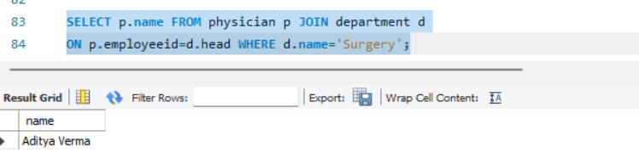
SELECT p.name FROM physician p JOIN department d
ON p.employeeid=d.head WHERE d.name='Surgery';

Step 20 — Question 15: JOIN + ORDER BY
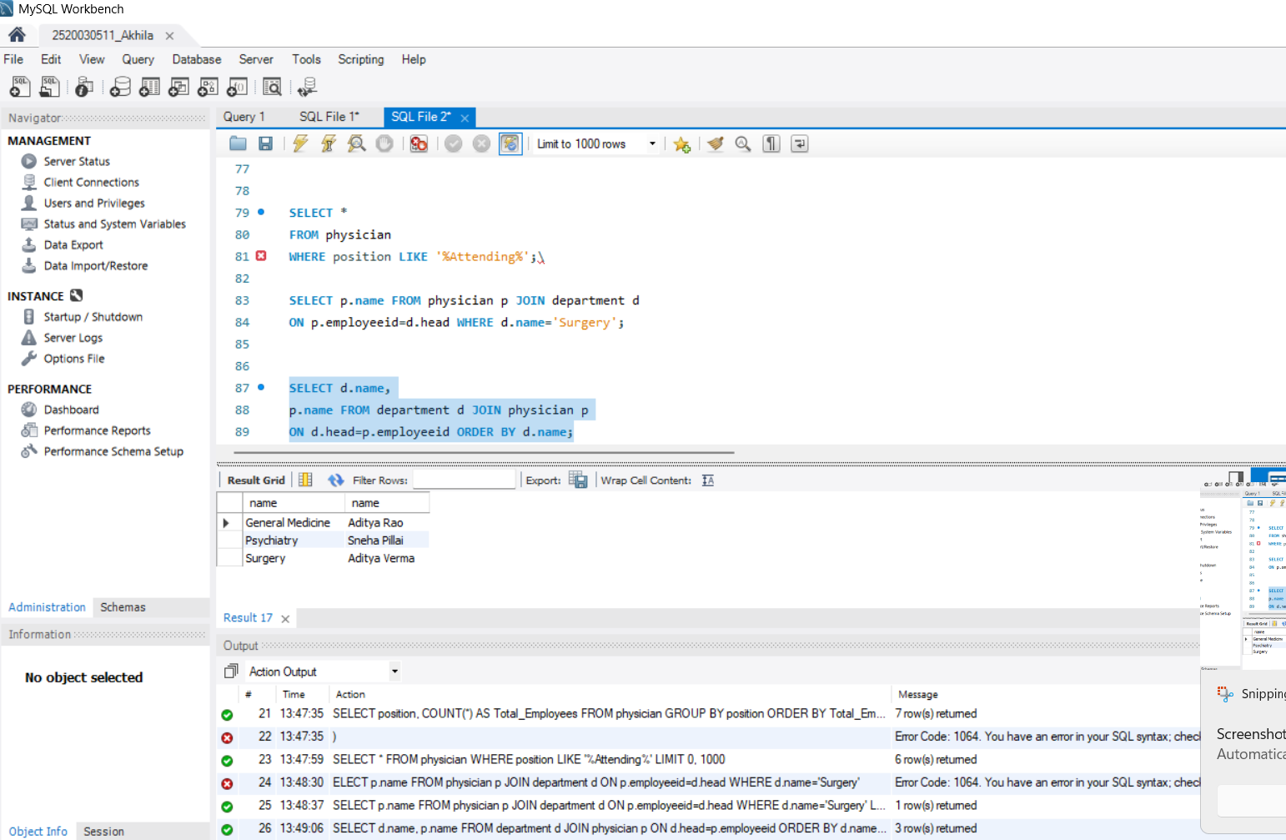
SELECT d.name,
p.name FROM department d JOIN physician p
ON d.head=p.employeeid ORDER BY d.name;

Step 21 — Question 16: WHERE + NOT LIKE
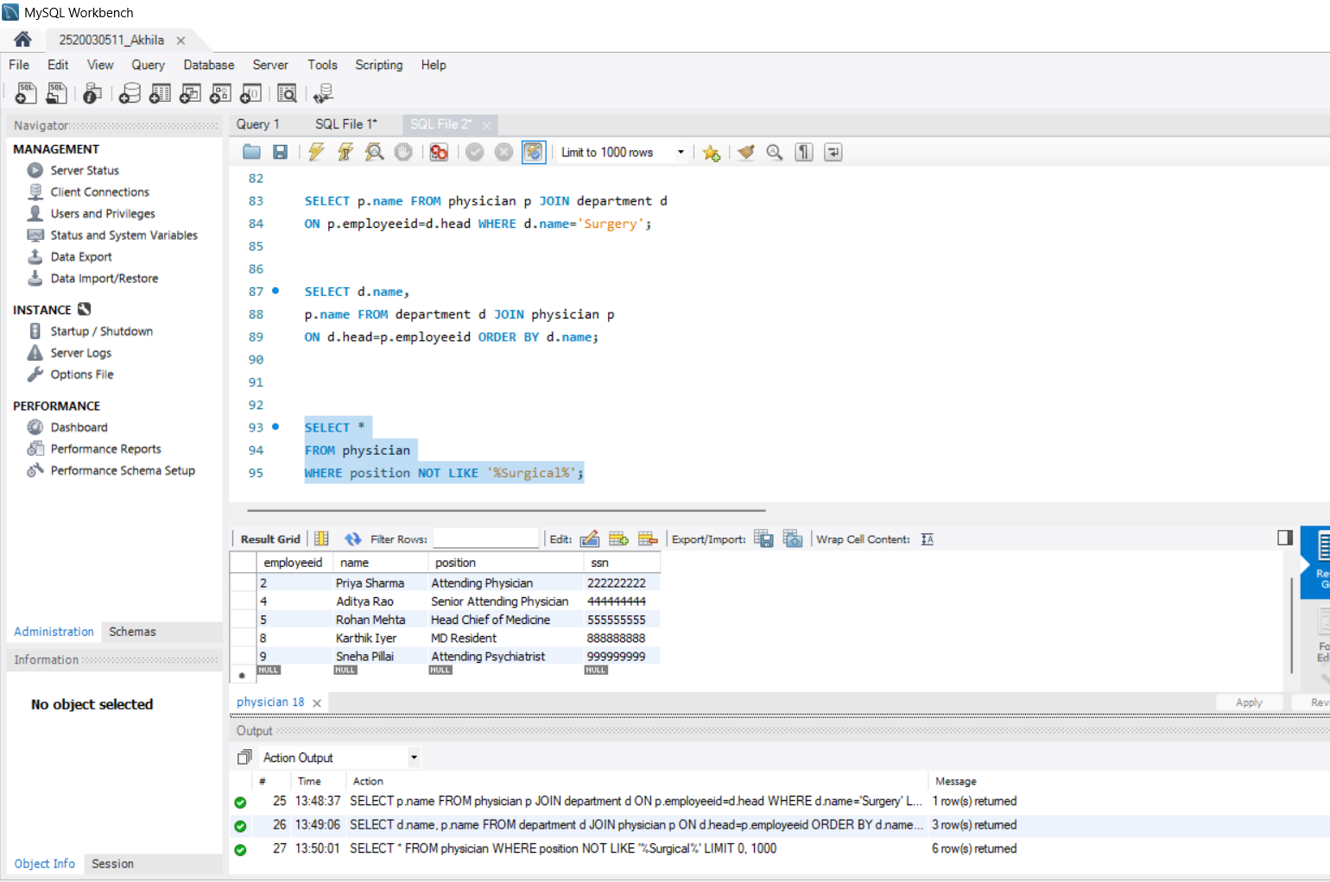
SELECT *
FROM physician
WHERE position NOT LIKE '%Surgical%';

Step 22 — Question 17: COUNT + HAVING
SELECT position,
COUNT(*) AS Total FROM physician
GROUP BY position HAVING COUNT(*) >= 2;

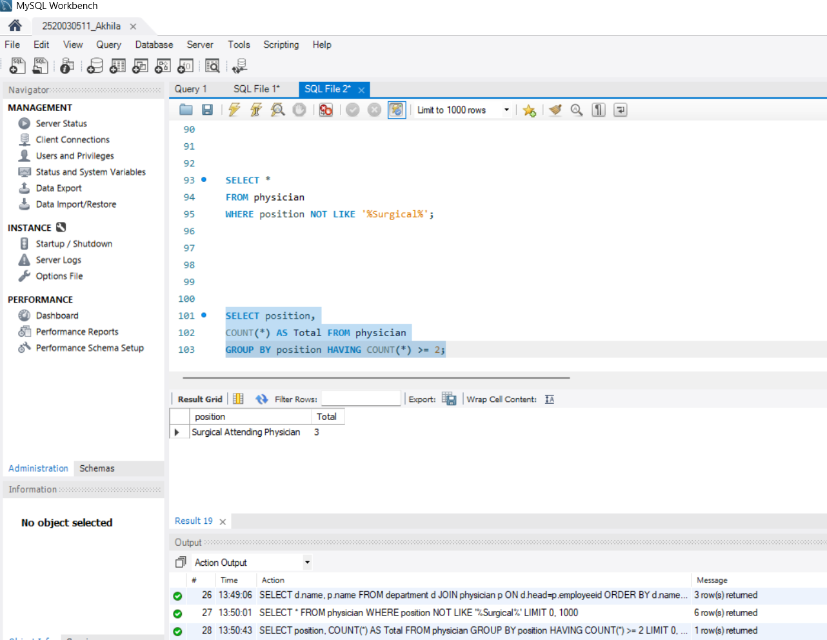

Step 23 — Question 18: EXISTS.
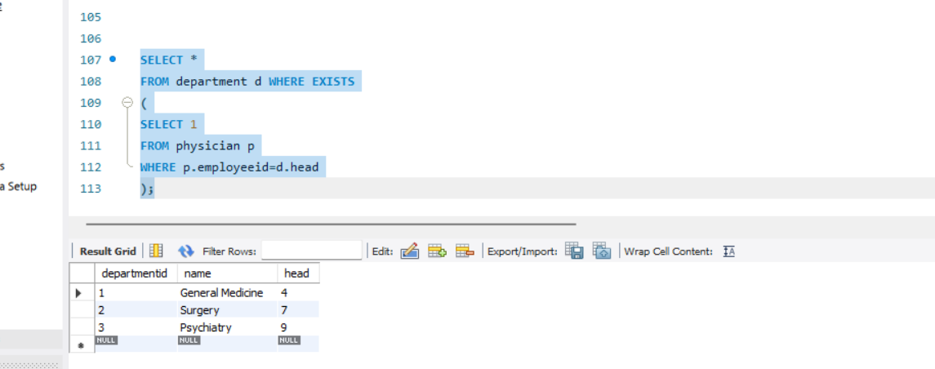
SELECT *
FROM department d WHERE EXISTS
(
SELECT 1
FROM physician p
WHERE p.employeeid=d.head
);

Step 24 — Question 19: MAX()
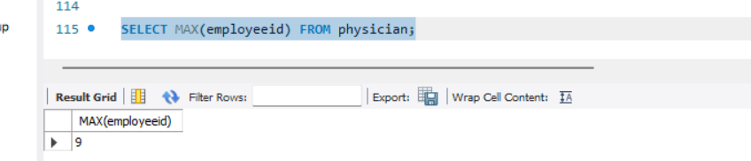
SELECT MAX(employeeid) FROM physician;

Step 25 — Question 20: MIN()
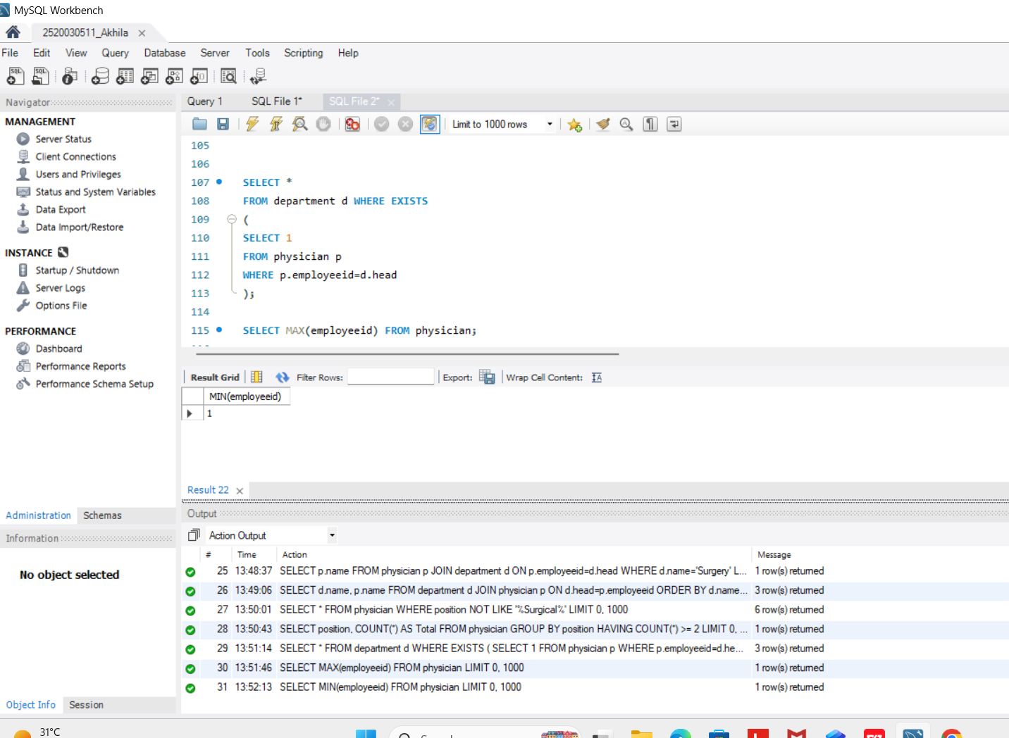
SELECT MIN(employeeid) FROM physician;

